Dream Country: Monster Masquerade

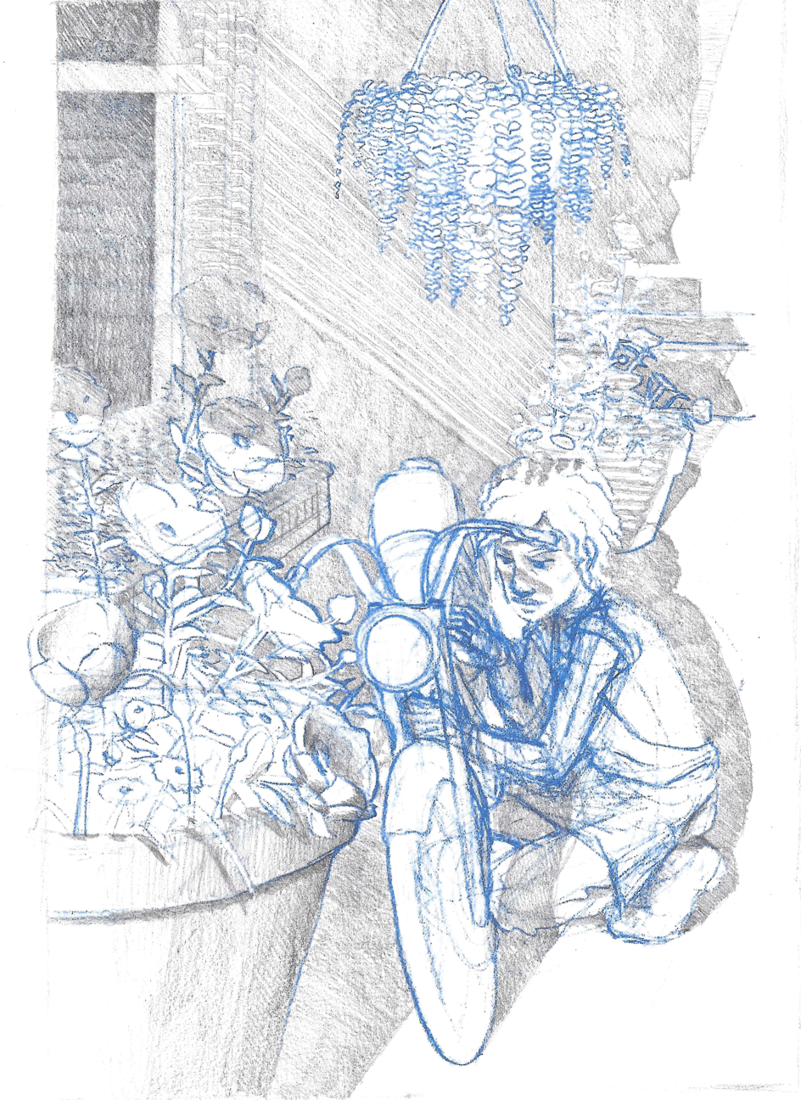

Table of Contents

Executive summary

Dust Jacket

Character Descriptions:

Player Character

Boris

Eiderdawn

Anette

Charis

Veda

Darius

Alvin

Preston

Pidge

Orlando

Transmuter

Creator

Destroyer

Gameplay Descriptions:

Intro

Rising Action

Game Branch One

Yes Path

No Path

Dream Re-Entry

Help or Hurt

Climax

Destroy

Transmute

Create

“Perfect” Bad End

“Perfect” Good End

High Concept:

What if you could share a dream with someone else? Find yourself in a dream of a masquerade ball full of enchanted monsters, befriend them and choose whether to return to the waking world or let the dream continue forever.

Game Genre:

Fantasy Dating Sim/Visual Novel

Platform:

PC, iOS, Android

Target Audience:

Primary: 17 – 35 -year-old women that typically consume dating games.

Secondary: 17 -45 -year-old consumers interested in platonic friendship stories and stories about non-binary characters.

Anticipated ESRB Rating:

E

Key Features:

Ten romanceable characters to choose from

Four-plus endings to play through

Write and receive letters from the characters

Explore the Monster Masquerade castle and grounds to find all the interactions and secrets

Tap along to fun dance minigames to unlock the monsters

Dust Jacket:

You recently convalesced from a long illness. It was thought to be fatal, but you miraculously recovered. At 19-years-old and with few friends or direction for what to do next, your only desire is to fix up your classic motorcycle and ride away. Frustrated at your mom’s insistence that you get your GED and apply for college, you escape into a dream that you are attending a masquerade ball unlike anything you have seen in waking life. Surrounded by uncanny, grotesque suitors you while the endless night away. Chatting, dancing and dining with the various monsters you begin to find they have a certain charm and magnetism you can’t fathom. A darker secret lies behind the dream world that hosts this elegant affair. Can you free your newfound companions from the endless ball? Or will you continue the masque forever?

Character Descriptions

Name:

One Sentence Description:

Convalescing from a mysterious illness that threw their normal life off track, all they want to do is get their vintage motorcycle fixed and feel free.

Appearance Description:

Our player character is a 5’7” light-skinned black 19-year-old. Their eyes are brown with hooded eyelids, and prominent cheekbones, lending them a friendly, heart-shaped face. They have a wide, slightly upturned nose and full lips. They wear their hair short, about three-to-four inches in length, forming curls and waves and flipping up at the neckline. They wear their hair minimally styled, parted above the right eye. Their hair is brown with naturally occurring auburn and golden highlights.

They wear a pair of woven motorcycle riding pants, and lace-up riding boots with a strap detail. On top is a plain white t-shirt, the short sleeves rolled up to the shoulder of the garment, but dipping off the actual shoulder due to the character’s thin frame. Over the outfit, our character wears a discarded bakery apron, stained with motor oil from repairing the motorcycle. Our player character is also seen wearing latex gloves to protect his hands while performing the repairs.

Visual Design:

|  |  |
| --- | --- |
|  |  |

Personality Architecture:

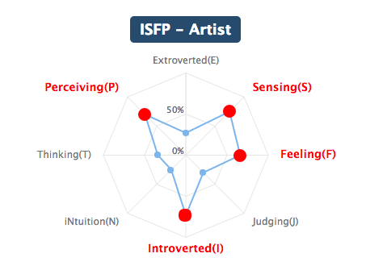

Backstory:

Attributes:

Behaviors:

Character Purpose:

Relationships with Other Characters:

Sample Dialogue:

Vocabulary of Motion:

Name: Boris

One Sentence Description:

A cross between Porco Rosso and King Gator from “All Dogs go to Heaven.”

Appearance Description:

Boris is a Frog Monster, he stands at 5’8” tall and weighs 225 pounds. He is top-heavy, carrying most of his volume in his chest and his dual vocal sacs. Boris has muscled, powerful arms and a strong chest. His head should have a soft sloping shape when he is bored or disinterested, and a drawn, wide appearance like a full tulip when elated. The shape of his face and vocal sacs have a tendency to transmogrify based on whether he is speaking, singing, or at rest. His eyes have a golden color.

He wears a doublet and some variation of trousers, breeches, or hose depending on mood. He wears a shirt with full sleeves and narrow cuffs (long or short). The cuffs of his trousers or breeches should extend to his ankle, leaving his webbed feet exposed. He wears a wide belt with an ornate buckle and a shoulder holster beneath his doublet that holds a fine revolver. The holder should only be revealed when his doublet is open.

Boris has scars on the middle and ring fingers of his right hand.

Visual Design:

|  |  |
| --- | --- |
| /var/folders/nn/9zs186kw8xj8zq001s7c6t2r0000gq/T/com.evernote.Evernote/WebKitDnD.GtFU2y/Evernote Camera Roll 20161002 002730.jpg | /var/folders/nn/9zs186kw8xj8zq001s7c6t2r0000gq/T/com.evernote.Evernote/WebKitDnD.I5vLaw/Evernote Snapshot 20161002 001938.png |

Personality Architecture:

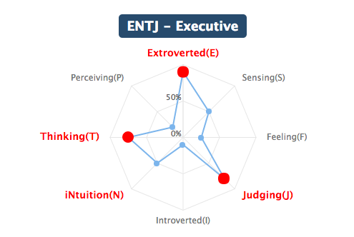

Backstory:

Free, unstructured play, in the country (image: clotheslines in the breeze), singing in the choir on Sundays. Former missionary or soldier? Obsessed with pistols and guns, appreciation of finely crafted, precisely machined items

When the PC was hospitalized he often felt drowned out by the voices around him, parents, doctors, nurses, lawyers. In his weakened state wished to have a booming voice that could silence all the cacophony around. A voice that would advocate for what made him feel best and stop the intrusive treatments that he already knew would cause more harm than good.

Attributes:

Behaviors:

Character Purpose:

Fear of Growing Old/ Mortality

Initial Problems: It’s time for him to retire from his dangerous work, but he’s not sure what to do in retirement with his battle-ready reflexes.

Current Problems: Wants to meet and befriend everyone at the party but some of the guests are cold, standoffish, or hard to pin down

How will it get worse: Darius will provoke him into a fight which will turn even more of the guests he wants to impress against him.

Relationships with Other Characters:

Closest Friends: Charis, Eiderdawn

Acquaintances: Anette

Enemies: Darius

Sample Dialogue:

Vocabulary of Motion:

Name: Eiderdawn

One Sentence Description:

“He thinks I’m a spy or a gossip, just like everybody else; I’m not, I’m cautious, I’m vigilant, I’m a defender.”

Appearance Description:

A monstrous type of angel known as a throne. Eiderdawn stands at 6’4” tall and weighs 135 lbs. She is thin and angular with long legs and delicate fingers. Upon her shoulder sits her grotesque head of four constantly shifting fleshy bands from which wink numerous eyes. Like Boris the shape of her head shifts depending on her mood. The space where her head joins her neck is hidden by one large eye which remains stationary in relationship to the position of the camera, always facing it directly.

She wears a double-breasted jacket with long sleeves, pagoda shoulders, and a mandarin collar that cuts away from the body into a long tail. Beneath she wears leggings and thigh-high boots or closefitting shoepants. There is a large embellishment on the front of the jacket just above the center of her chest.

She often will engage in nervous gestures, crossing her arms over her chest, clasping her hands in front or behind her body. She has scars on her knees and shins.

Visual Design:

|  |  |
| --- | --- |
| /var/folders/nn/9zs186kw8xj8zq001s7c6t2r0000gq/T/com.evernote.Evernote/WebKitDnD.PBkKq8/Evernote Snapshot 20160910 211254.png | /var/folders/nn/9zs186kw8xj8zq001s7c6t2r0000gq/T/com.evernote.Evernote/WebKitDnD.iinKal/Evernote Camera Roll 20161002 235343.jpg |

Personality Architecture:

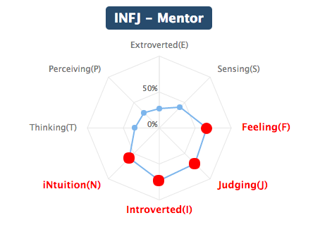

Backstory:

I get worried that people think I’m spying on them, or that I’m not interested in talking to them cause my eyes are always on something else. But I can’t help it. And everyone that sees me, judges me, with the same sense that is my curse. It’s really hard to look at myself and know who I am. I look so odd, not cuddly or graceful or talented like the others, and it’s so hard not to look at the others. But when I close my eyes I feel safe. The possibilities shrink down and there is just the current moment. And me expanding.

I can feel my mind and my heart. I can remember what it felt like to for someone to hold my hand and lead me everywhere, not knowing where I was going. I can remember getting upset and stubbing my toes on sidewalk curbs, and wondering what was flashing beyond the flesh of my eyelids. I remember what it felt like to be safe and present.

I love my eyes. They are what people notice about me, they let me stay alert and prepared! They come in so many colors and sizes. They make me like my favorite animal, the spider. Spiders humbly protect their households and keep intruders out! They guard doorways and thresholds and never ask for anything in return. Spiders never stop building, no matter how many times they watch their homes get swept away. I love my eyes, just some days I wish for a fight that might blacken almost all of them.

Eiderdawn grew up lonesome, with a single parent, and usually entertained herself. She is very conflicted about her purpose, clearly special, gifted from a young age, but disfigurement gave much unwanted attention.

Once the PC was sick, they felt constantly the center of unwanted attention, constantly under surveillance, voiceless could only helplessly watch what was happening to them. While bedridden the PC could only observe the world without participating in it.

Attributes:

Behaviors:

Character Purpose:

One of the earliest relationships that you develop in the game Eiderdawn helps you confront: Fear of being outcast, fear of showing true self, fear of being different and being rejected.

She believes she will save the world and she’s scared that’s a lie, that her appearance, everything she is a misfortune rather than a blessing.

Is afraid that the other partygoers dislike her, see her a busybody and think she is unattractive.

She will inadvertently reveal a secret about the masquerade and bring the wrath of the creator on her.

Relationships with Other Characters:

Closest Friends: Anette, Destroyer

Acquaintances: Charis, Boris

Enemies: Darius

Sample Dialogue:

Vocabulary of Motion:

Name: Anette

One Sentence Description:

A highly competitive professional dancer, beauty is everything to her, and she’s willing to do anything to get it.

Appearance Description:

A centipede monster with a cherubic face (like Mae West).

Visual Design:

|  |  |
| --- | --- |
| /var/folders/nn/9zs186kw8xj8zq001s7c6t2r0000gq/T/com.evernote.Evernote/WebKitDnD.5dqMWv/Evernote Snapshot 20161002 001812.png |  |

Personality Architecture:

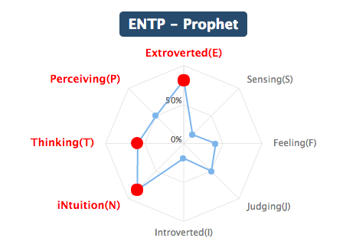

Backstory:

Attributes:

Behaviors:

Character Purpose:

Insecurity about looks

Relationships with Other Characters:

Sample Dialogue:

Vocabulary of Motion:

Name: Charis

One Sentence Description:

Appearance Description:

Visual Design:

|  |  |
| --- | --- |
| /var/folders/nn/9zs186kw8xj8zq001s7c6t2r0000gq/T/com.evernote.Evernote/WebKitDnD.r9N6VT/Screenshot 2017-03-23 22.32.12.png | /var/folders/nn/9zs186kw8xj8zq001s7c6t2r0000gq/T/com.evernote.Evernote/WebKitDnD.vj2T8n/Screenshot 2017-03-23 22.32.01.png |

Personality Architecture:

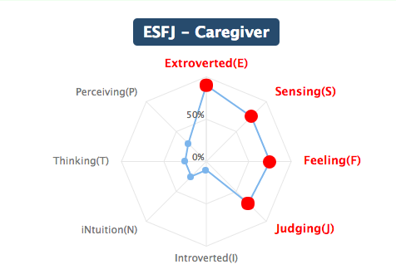

Backstory:

Attributes:

Behaviors:

Character Purpose:

Ashamed of not living up to family’s expectations (shirking responsibility), Afraid of losing her family, Causing harm to her family through her inaction/refusal to engage with her family’s gang.

Relationships with Other Characters:

Sample Dialogue:

Vocabulary of Motion:

Name:Veda

One Sentence Description:

Appearance Description:

Visual Design:

|  |  |
| --- | --- |
| /var/folders/nn/9zs186kw8xj8zq001s7c6t2r0000gq/T/com.evernote.Evernote/WebKitDnD.WyOwFN/Evernote Snapshot 20161023 182442.png |  |

Personality Architecture:

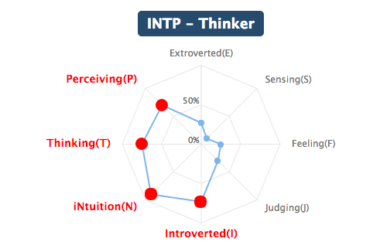

Backstory:

Attributes:

Behaviors:

Character Purpose:

Fear of Intimacy, Fear of Attachment

Relationships with Other Characters:

Sample Dialogue:

Vocabulary of Motion:

Name: Darius

One Sentence Description:

Appearance Description:

Visual Design:

|  |  |
| --- | --- |
| /var/folders/nn/9zs186kw8xj8zq001s7c6t2r0000gq/T/com.evernote.Evernote/WebKitDnD.2IUb6o/Evernote Camera Roll 20161113 213903.png | /var/folders/nn/9zs186kw8xj8zq001s7c6t2r0000gq/T/com.evernote.Evernote/WebKitDnD.R7TrF5/Evernote Camera Roll 20161104 185143.png |

Personality Architecture:

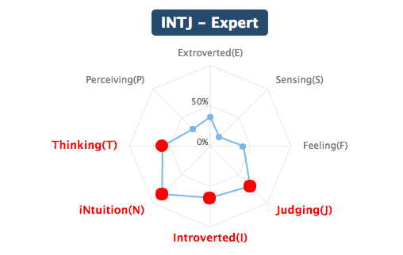

Backstory:

Attributes:

Behaviors:

Character Purpose:

Being misunderstood, fear of not being special.

Relationships with Other Characters:

Sample Dialogue:

Vocabulary of Motion:

Name: Alvin

One Sentence Description:

Appearance Description:

Visual Design:

|  |  |
| --- | --- |
| /var/folders/nn/9zs186kw8xj8zq001s7c6t2r0000gq/T/com.evernote.Evernote/WebKitDnD.sEPUiv/Evernote Snapshot 20161023 182225.png |  |

Personality Architecture:

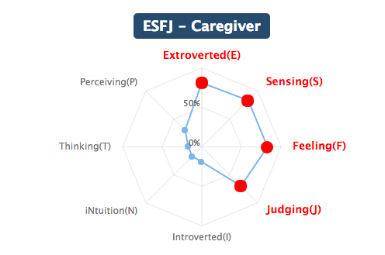

Backstory:

Attributes:

Behaviors:

Character Purpose:

Fear of permanent disability, not being useful, not being productive.

Relationships with Other Characters:

Sample Dialogue:

Vocabulary of Motion:

Name: Preston

One Sentence Description:

Appearance Description:

Visual Design:

|  |  |
| --- | --- |
| /var/folders/nn/9zs186kw8xj8zq001s7c6t2r0000gq/T/com.evernote.Evernote/WebKitDnD.rjOcqp/Evernote Snapshot 20161023 182541.png |  |

Personality Architecture:

Backstory: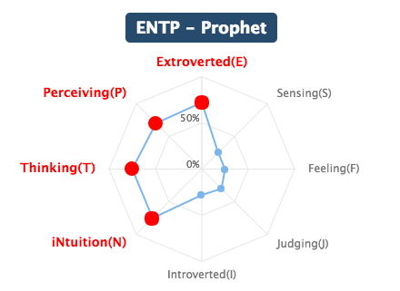

Attributes:

Behaviors:

Character Purpose:

Inferiority complex, afraid of others perceiving them as dumb.

Relationships with Other Characters:

Sample Dialogue:

Vocabulary of Motion:

Name: Pidge

One Sentence Description:

Appearance Description:

Visual Design:

|  |  |
| --- | --- |
| /var/folders/nn/9zs186kw8xj8zq001s7c6t2r0000gq/T/com.evernote.Evernote/WebKitDnD.iLoxGf/Evernote Camera Roll 20161030 232638.png |  |

Personality Architecture:

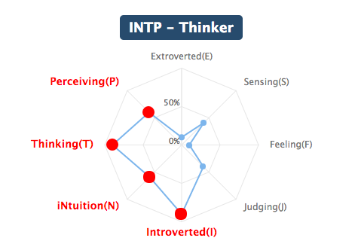

Backstory:

Attributes:

Behaviors:

Character Purpose:

Afraid of being alone, codependent.

Depending on the amount of information you have gathered on the Transmuter, Pidge will seek out a private audience with the player character. If you successfully build a friendship with Pidge, her turning will reveal that the Monsters of the Masquerade were manifested from the Player Character’s own insecurities.

Relationships with Other Characters:

Sample Dialogue:

Vocabulary of Motion:

Name: Orlando

One Sentence Description:

Appearance Description:

Visual Design:

|  |  |  |
| --- | --- | --- |
| /var/folders/nn/9zs186kw8xj8zq001s7c6t2r0000gq/T/com.evernote.Evernote/WebKitDnD.oV8HNy/Evernote Snapshot 20161023 182057.png | /var/folders/nn/9zs186kw8xj8zq001s7c6t2r0000gq/T/com.evernote.Evernote/WebKitDnD.C39QGK/IMG_4429.JPG | /var/folders/nn/9zs186kw8xj8zq001s7c6t2r0000gq/T/com.evernote.Evernote/WebKitDnD.o1NUol/IMG_4430.JPG |

Personality Architecture:

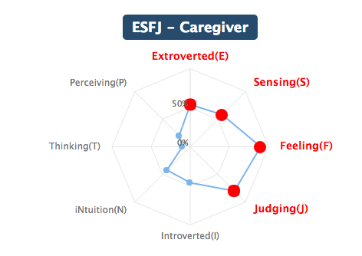

Backstory:

Attributes:

Behaviors:

Character Purpose:

Fear of never finding romantic fulfillment, being emasculated, fear of failure, insecurity/helplessness about controlling emotional vulnerability.

Relationships with Other Characters:

Sample Dialogue:

Vocabulary of Motion:

Name: Transmuter

One Sentence Description:

Appearance Description:

Visual Design:

|  |  |
| --- | --- |
| /var/folders/nn/9zs186kw8xj8zq001s7c6t2r0000gq/T/com.evernote.Evernote/WebKitDnD.5MD4pw/IMG_3827.png |  |

Personality Architecture:

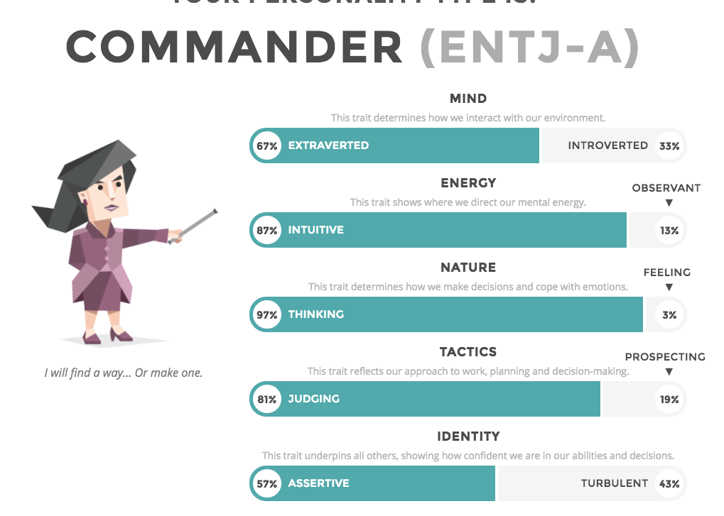

Backstory:

Attributes:

Behaviors:

Character Purpose:

Relationships with Other Characters:

Sample Dialogue:

Vocabulary of Motion:

Name: Creator

One Sentence Description:

Appearance Description:

Visual Design:

|  |  |
| --- | --- |
| /var/folders/nn/9zs186kw8xj8zq001s7c6t2r0000gq/T/com.evernote.Evernote/WebKitDnD.Lvp7cz/Evernote Camera Roll 20161020 202702.jpg | /var/folders/nn/9zs186kw8xj8zq001s7c6t2r0000gq/T/com.evernote.Evernote/WebKitDnD.61YTHQ/IMG_3869.png |

Personality Architecture:

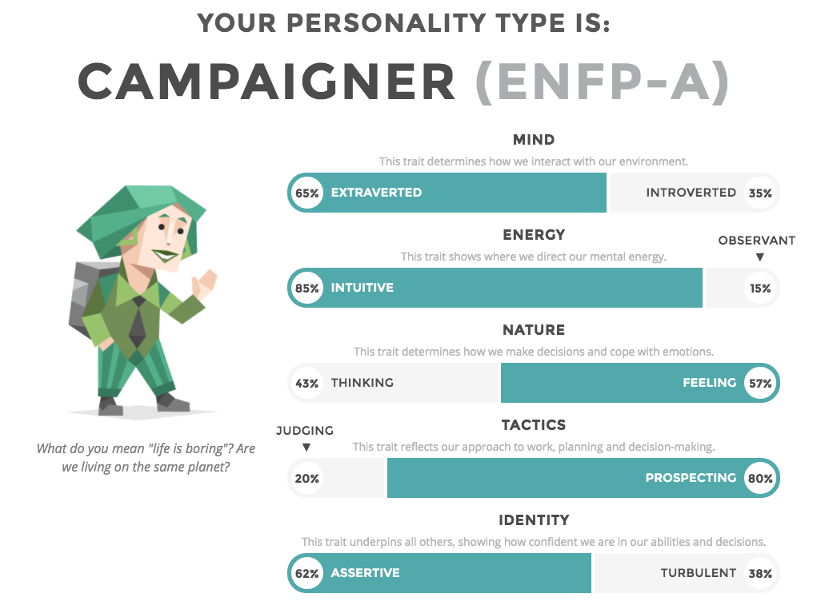

Backstory:

Attributes:

Behaviors:

Character Purpose:

Relationships with Other Characters:

Sample Dialogue:

Vocabulary of Motion:

Name: Destroyer

One Sentence Description:

Appearance Description:

Visual Design:

|  |  |
| --- | --- |
| /var/folders/nn/9zs186kw8xj8zq001s7c6t2r0000gq/T/com.evernote.Evernote/WebKitDnD.XAbu4V/Evernote Camera Roll 20161019 230828.jpg | /var/folders/nn/9zs186kw8xj8zq001s7c6t2r0000gq/T/com.evernote.Evernote/WebKitDnD.BsitZx/Evernote Snapshot 20161019 231024.png |

Personality Architecture:

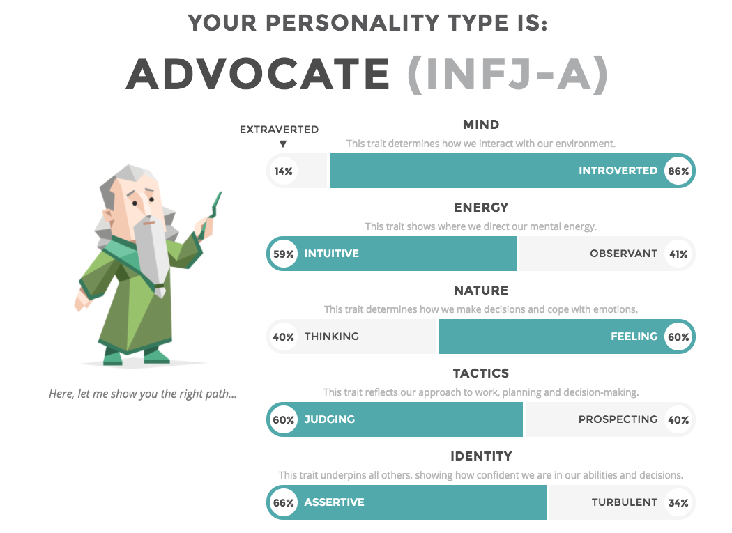

Backstory:

Attributes:

Behaviors:

Character Purpose:

Relationships with Other Characters:

Sample Dialogue:

Vocabulary of Motion:

Citations:

Personality Tests:

Characters: https://www.arealme.com/16types/en/

Dreamers: https://www.16personalities.com/entj-personality